Civil war in Sierra Leone

UNSC Resolution: | 1132
Date of adoption: | 8 October 1997
Operative paragraph: | 1
Demand number: | 1

Megan MacKenzie

Wording of demand
take immediate steps to relinquish power in Sierra Leone and make way for the restoration of the democratically-elected Government and a return to constitutional order

List of addressees of the demand

Military Junta (Sierra Leone)

Short-term compliance

Description of the addressee(s)’ conduct

Shortly thereafter [Passing of Security Council Resolution 1132], Koroma formally agreed to relinquish power. Meeting with representatives of regional and international organizations in the Guinean capital in October 1997, Koroma signed the Conakry Agreement, which called for Kabbah to be reinstalled by April 1998. 149

6. Clashes between AFRC troops and ECOMOG forces were reported to have taken place in Freetown and around July, 25 kilometres from Freetown, where ECOMOG troops are based and were attacked by the AFRC.

To date, it appears that the military junta has not complied with
paragraph 1 of resolution 1132 (1997).

Assessment

Short-term compliance
x No or marginal compliance (1) | Medium low compliance (2) | Medium high compliance (3) | Full or almost full compliance (4)

Considerations underlying the assessment
There is evidence of verbal commitment to this command by the Military Junta, yet their actions show clear violations of the demand. The Security Council Report makes it clear that this demand was not complied with.

Medium-term compliance

Description of the addressee(s)’ conduct

Soon after the Conakry Agreement was concluded [January 1998], however ,it became apparent to many that Koroma could not hold up his end of the bargain.....

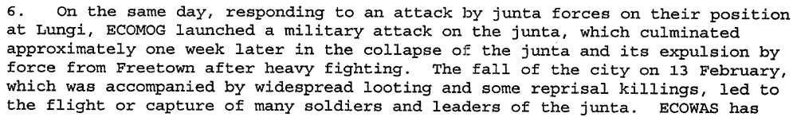

Assessment

Medium-term compliance
x No or marginal compliance (1) | Medium low compliance (2) | Medium high compliance (3) | Full or almost full compliance (4)

Considerations underlying the assessment
The demand is clear that the Junta should take ‘immediate steps to relinquish power.’ The Junta lost power during this period of time but it was through force, not as a result of relinquishing it.

Depth of demand

Assessment

Level of depth of demand
Low depth of demand (1) | Medium depth of demand (2) | x High depth of demand (3)

Considerations underlying the assessment
For the Junta, relinquishing power and making way for a democratically elected government required a drastic alteration of the entire raison d’etre. They had achieved power through force and had removed a democratically elected government.

Level of confidence about coding decisions

Level of confidence about coding decision
Extremely high | x High | Moderate

Comments to IPI (if any)

Civil war in Sierra Leone

UNSC Resolution: | 1132
Date of adoption: | 8 October 1997
Operative paragraph: | 2
Demand number: | 1

Megan MacKenzie

Wording of demand

end all acts of violence and cease all interference with the delivery of humanitarian assistance to
the people of Sierra Leone

List of addressees of the demand

Military Junta (Sierra Leone)

Short-term compliance

Description of the addressee(s)’ conduct

13. The serious humanitarian situation in the country poses a dilemma for the international community because the security and safety of both personnel and humanitarian supplies cannot be assured in the country under prevailing conditions.

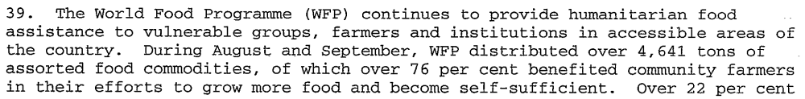

Assessment

Short-term compliance
x No or marginal compliance (1) | Medium low compliance (2) | Medium high compliance (3) | Full or almost full compliance (4)

Considerations underlying the assessment
There is strong evidence of continued hostilities initiated by the Junta in the country during this period of time. The research also indicates that some humanitarian assistance was being carried out, but that the security situation in the country was hindering this process.

Medium-term compliance

Description of the addressee(s)’ conduct
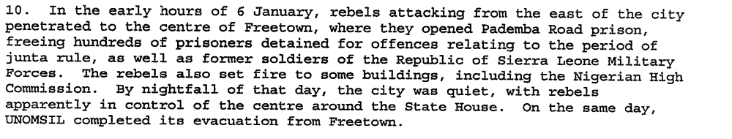
In February 1998, Nigerian troops….launched an assault on rebel-held Freetown. Koroma and the AFRC were driven from power by the end of February, and Kabbah returned to Freetown on March 10, 1998. The West African force did not fully neutralize the AFRC and RUF threat, however, and fighting continued in the eastern and norther parts of the country. By December, the RUF was advancing from the east toward Freetown…Some accounts mention only the RUF role in the subsequent siege of Freetown, but numerous credible sources credit the ex-SLA/AFRC with organizing the attack, in which some RUF troops participated.

Assessment

Medium-term compliance
x No or marginal compliance (1) | Medium low compliance (2) | Medium high compliance (3) | Full or almost full compliance (4)

Considerations underlying the assessment
There was intense fighting during this period and the AFRC/RUF caused drastic instability during this period of time.

Depth of demand

Assessment

Level of depth of demand
Low depth of demand (1) | Medium depth of demand (2) | x High depth of demand (3)

Considerations underlying the assessment
Ending all acts of violence was a high depth demand because at this point, the AFRC and RUF had gained most of the power and authority through force. They were formed as an armed group, not a political party.

Level of confidence about coding decisions

Level of confidence about coding decision
Extremely high | x High | Moderate

Comments to IPI (if any)

Civil war in Sierra Leone

UNSC Resolution: | 1162
Date of adoption: | 17 April 1998
Operative paragraph: | 3
Demand number: | 1

Megan MacKenzie

Wording of demand

promote national reconciliation in Sierra Leone, work towards this objective

List of addressees of the demand

Government of Sierra Leone, Armed Forces Revolutionary Council, Kamajors, Revolutionary United Front

Short-term compliance

Description of the addressee(s)’ conduct

Leaders of Sierra Leone's ousted junta have written a letter to United Nations Secretary-General Kofi Annan, blaming ECOMOG for recent atrocities against civilians but seeking an end to the fighting. U.N. officials in Freetown told the Integrated Regional Information Network for West Africa (IRIN) that the letter, which was sent to their office and was also published in the local newspaper Punch, appeared to be authentic. It was dated May 10, but apparently only reached Freetown in recent days, U.N. officials said.
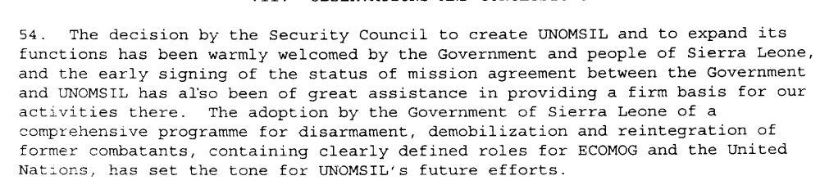

Assessment

Short-term compliance
No or marginal compliance (1) | Medium low compliance (2) | x Medium high compliance (3) | Full or almost full compliance (4)

Considerations underlying the assessment
The demand asks for the promotion of peace and reconciliation and in the short term, it seems that the parties made an effort to comply. There is not much indication of the Kamajors’ response to this demand.

Medium-term compliance

Description of the addressee(s)’ conduct

December 1998
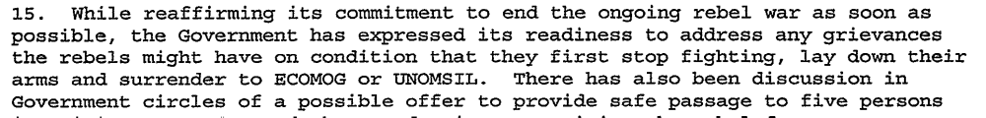
January 1999
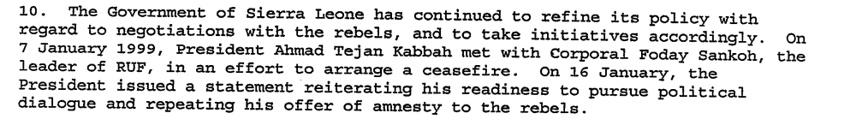
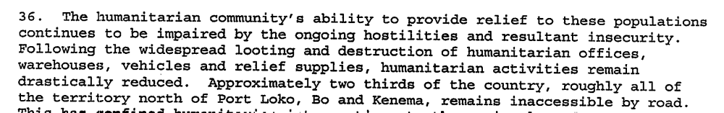

Assessment

Medium-term compliance
x No or marginal compliance (1) | Medium low compliance (2) | Medium high compliance (3) | Full or almost full compliance (4)

Considerations underlying the assessment
The Government of Sierra Leone made clear efforts to work towards peace and reconciliation during this period. Overall, these two years were some of the most violent in the country’s history and were marked by brutally and human rights abuses.

Depth of demand

Assessment

Level of depth of demand
Low depth of demand (1) | x Medium depth of demand (2) | High depth of demand (3)

Considerations underlying the assessment
Promoting peace and reconciliation is a medium depth demand primarily because of the verb ‘promoting.’ The parties could promote peace and reconciliation- at least at a basic level- without completely altering their own behaviors.

Level of confidence about coding decisions

Level of confidence about coding decision
Extremely high | x High | Moderate

Comments to IPI (if any)

Civil war in Sierra Leone

UNSC Resolution: | 1171
Date of adoption: | 5 June 1998
Operative paragraph: | 4
Demand number: | 1

Megan MacKenzie

Wording of demand
mark, register and notify to the Committee all imports made by it of arms and related materiel

List of addressees of the demand

Government of Sierra Leone

Short-term compliance

Description of the addressee(s)’ conduct
However, there was one factor that underpinned all of the others in sustaining the violence, and that was the continued supply of weapons, many of them paid for by the illegal sale of diamonds. Sierra Leone does not manufacture weapons. The outside world had to be prepared to supply them, and supply them it did.

Assessment

Short-term compliance
No or marginal compliance (1) | x Medium low compliance (2) | Medium high compliance (3) | Full or almost full compliance (4)

Considerations underlying the assessment
There is very little research indicating whether or not the Government of Sierra Leone complied with this demand in the short term.

Medium-term compliance

Description of the addressee(s)’ conduct

Currently, the government of Sierra Leone is relying on the AFRC/ex-SLA and the CDFs to help the Sierra Leonean army combat the RUF. Under these circumstances, any weapons provided to the government risk being handed out to irregular, undisciplined, and unaccountable fighters. In fact, an unconfirmed May 22 report in The Independent suggested that the Sierra Leonean government already had begun to re-arm irregular forces. This raises the possibility that the planned provision of arms from the United Kingdom will enable the Sierra Leonean government to distribute weapons from its own stocks to the AFRC/ex-SLA and the CDF, especially as it has been reported that as many as 10,000 British weapons already in Freetown may be made available to the Sierra Leonean government.

The clandestine arms dealers used by United Sates and other countries' intelligence agencies during the Cold War continue to operate as free agents today, arming warlords such as Angola's Jonas Savimbi and Sierra Leone's Foday Sankoh—both under UN embargoes.

Assessment

Medium-term compliance
x No or marginal compliance (1) | Medium low compliance (2) | Medium high compliance (3) | Full or almost full compliance (4)

Considerations underlying the assessment
There is very little research indicating whether or not the Government of Sierra Leone complied with this demand in the short term.

Depth of demand

Assessment

Level of depth of demand
Low depth of demand (1) | x Medium depth of demand (2) | High depth of demand (3)

Considerations underlying the assessment
Complying with this demand required coordination and the dedication of resources.

Level of confidence about coding decisions

Level of confidence about coding decision
Extremely high | High | x Moderate

Comments to IPI (if any)
I had a very hard time finding research that applied directly to this demand. As a result, I am not confident about my coding decisions.

Civil war in Sierra Leone

UNSC Resolution: | 1181
Date of adoption: | 13 July 1998
Operative paragraph: | 1
Demand number: | 2

Megan MacKenzie

Wording of demand

lay down their arms immediately

List of addressees of the demand
Armed Forces Revolutionary Council, Revolutionary United Front

Short-term compliance

Description of the addressee(s)’ conduct

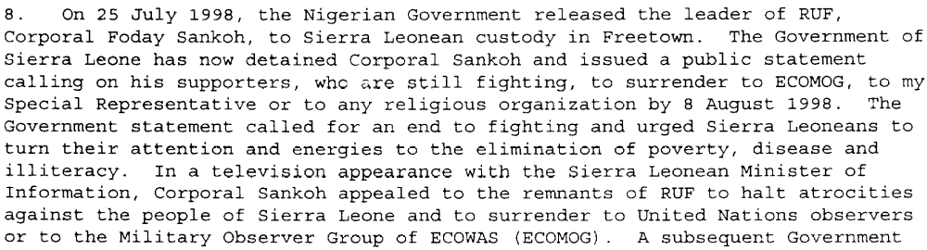

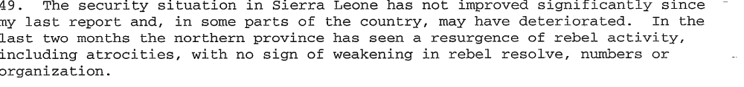
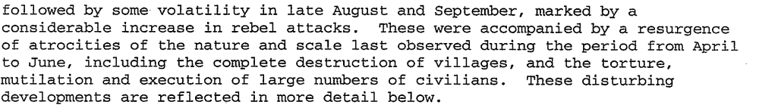

Assessment

Short-term compliance
x No or marginal compliance (1) | Medium low compliance (2) | Medium high compliance (3) | Full or almost full compliance (4)

Considerations underlying the assessment
Foday Sankoh made a request to his troops to stop fighting and to surrender to ECONOG, yet most research indicates that the RUF and AFRC continued to invoke violence and commit human rights atrocities.

Medium-term compliance

Description of the addressee(s)’ conduct
January 1998
Operation No Living Thing largely directed by RUF soldiers on January 6, 1999
According to Lansana Gberie “civilians were gunned down within their houses, rounded up and massacred on the streets, thrown from the upper floors of buildings, used as human shields, and burnt alive in cars and houses. They had their limbs hacked off with machetes, eyes gouged out with knives, hands smashed with hammers, and bodies burned with boiling water. Women and girls were systematically sexually abused, and children and young people abducted by the hundreds. (2005)

Assessment

Medium-term compliance
x No or marginal compliance (1) | Medium low compliance (2) | Medium high compliance (3) | Full or almost full compliance (4)

Considerations underlying the assessment
This is clearly one of the most violent periods in the country’s history. The parties did not lay down their arms; rather, they organized the most brutal massacre of Freetown’s history.

Depth of demand

Assessment

Level of depth of demand
Low depth of demand (1) | Medium depth of demand (2) | x High depth of demand (3)

Considerations underlying the assessment
At this stage the AFRC and RUF had attained most of their power and influence through violence; therefore, ceasing violence meant a marked change in their behavior and tactics.

Level of confidence about coding decisions

Level of confidence about coding decision
x Extremely high | High | Moderate

Comments to IPI (if any)

Civil war in Sierra Leone

UNSC Resolution: | 1181
Date of adoption: | 13 July 1998
Operative paragraph: | 2
Demand number: | 2

Megan MacKenzie

Wording of demand

promote national reconciliation in Sierra Leone, work together towards this objective

List of addressees of the demand

Government of Sierra Leone, Armed Forces Revolutionary Council, Civil Defence Forces , Revolutionary United Front

Short-term compliance

Description of the addressee(s)’ conduct

In July 1998, the ministry [Ministry of National Reconstruction, Resettlement, and Rehabilitation] was replaced by the National Committee for Disarmament, Debomilization, an dReintegration (NCDDR)…The NCDDR prepared an overall strategy for DDR…the committee’s goal was to disarm some 32,000combatants between July 1998 and Junuary 2000, including element s from the SLA, the AFRC, the RUF, the CDF, and child soldiers.

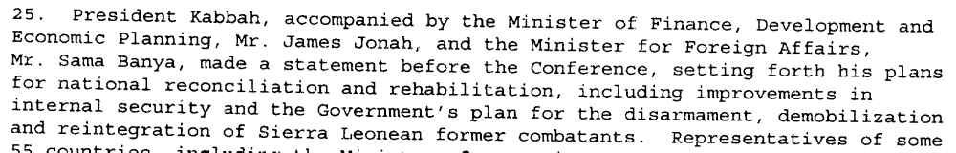

Assessment

Short-term compliance
x No or marginal compliance (1) | Medium low compliance (2) | Medium high compliance (3) | Full or almost full compliance (4)

Considerations underlying the assessment

During this period the Government of Sierra Leone made an effort to promote national reconciliation in the country. The demand, however, asks for the parties to work together towards this objective and the remaining parties clearly behaved in ways that created further insecurity rather than reconciliation.

Medium-term compliance

Description of the addressee(s)’ conduct

Operation No Living Thing largely directed by RUF soldiers on January 6, 1999
According to Lansana Gberie “civilians were gunned down within their houses, rounded up and massacred on the streets, thrown from the upper floors of buildings, used as human shields, and burnt alive in cars and houses. They had their limbs hacked off with machetes, eyes gouged out with knives, hands smashed with hammers, and bodies burned with boiling water. Women and girls were systematically sexually abused, and children and young people abducted by the hundreds. (2005)

By mid year (1999) the gov and the RUF has signed two negotiated settlements. (not direct- Kabbah offered Sankoh to rescind his death sentence if Sankoh would commit the RUF to a peaceful end to the civil war. Sankoh accepted. Peace negotiations commenced in Togo…procuced May 1999 cease-fire and Jly 1999 Lome Agreement.

Assessment

Medium-term compliance
No or marginal compliance (1) | x Medium low compliance (2) | Medium high compliance (3) | Full or almost full compliance (4)

Considerations underlying the assessment
The parties showed some important signs of working together on national reconciliation. Despite these positive efforts, this was still two of the most brutal years in the country’s history and the RUF and AFRC were invoking violence.

Depth of demand

Assessment

Level of depth of demand
Low depth of demand (1) | x Medium depth of demand (2) | High depth of demand (3)

Considerations underlying the assessment
Promoting national reconciliation is a medium depth demand primarily because of the verb ‘promoting.’ The parties could promote reconciliation- at least at a basic level- without completely altering their own behaviors.

Level of confidence about coding decisions

Level of confidence about coding decision
Extremely high | x High | Moderate

Comments to IPI (if any)

Civil war in Sierra Leone

UNSC Resolution: | 1181
Date of adoption: | 13 July 1998
Operative paragraph: | 12
Demand number: | 1

Megan MacKenzie

Wording of demand
strictly respect the status of UNOMSIL personnel, as well as organizations and agencies delivering humanitarian assistance throughout Sierra Leone, and respect human rights and abide by applicable rules of international humanitarian law

List of addressees of the demand

Government of Sierra Leone, Armed Forces Revolutionary Council, Civil Defence Forces , Revolutionary United Front

Short-term compliance

Description of the addressee(s)’ conduct
The security situation prevented the mission [UN mission] from deploying fully, however; indeed most of the force was withdrawn to Guinea under the Freetown siege.

Assessment

Short-term compliance
x No or marginal compliance (1) | Medium low compliance (2) | Medium high compliance (3) | Full or almost full compliance (4)

Considerations underlying the assessment
This research indicates an increase in the human rights abuses. In addition, the insecurity created by the parties hindered the UN mission. I have not included research specifying the activities of the Civil Defence Forces; however it is clear that overall, the demand was not complied with.

Medium-term compliance

Description of the addressee(s)’ conduct

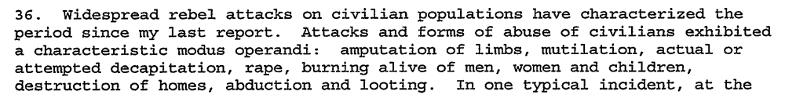

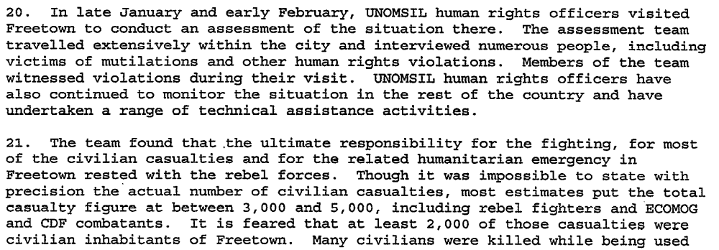
In May 2000 RUF rebels took over 400 UN peacekeepers hostage.

Assessment

Medium-term compliance
x No or marginal compliance (1) | Medium low compliance (2) | Medium high compliance (3) | Full or almost full compliance (4)

Considerations underlying the assessment
There is research indicating that human rights abuses peaked during this time, there were multiple and severe violations of human rights law, and the UN mission had to be suspended due to the severe security situation in January.

Depth of demand

Assessment

Level of depth of demand
Low depth of demand (1) | Medium depth of demand (2) | x High depth of demand (3)

Considerations underlying the assessment
This demand is complex and has several important aspects to it that would require the parties to pay attention to international laws and to change their behavior. It asked them to respect the UN mission and humanitarian organization, as well as human rights and international law.

Level of confidence about coding decisions

Level of confidence about coding decision
x Extremely high | High | Moderate

Comments to IPI (if any)

Eric G. Berman and Melissa T. Labonte, “Sierra Leone” in William J. Durch ed. Sierra Leone 21st Century Peace Operations. (Washington: United States Institute of Peace) p141.
United Nations Secretary General. REPORT OF THE SECRETARY-GENERAL ON THE SITUATION IN SIERRA LEONE. 21 October 1997
United Nations Secretary General. REPORT OF THE SECRETARY-GENERAL ON THE SITUATION IN SIERRA LEONE. 21 October 1997
Eric G. Berman and Melissa T. Labonte, “Sierra Leone” in William J. Durch ed. Sierra Leone 21st Century Peace Operations. (Washington: United States Institute of Peace) p149.
United Nations Secretary General. First Progress Report of the Secretary General on UNOMSIL. 12 August 1998.
United Nations Security Council. Second Progress Report of the Secretary General on UNOMSIL with plans for later phases of deployment. 16 October 1998.
United Nations Secretary General. REPORT OF THE SECRETARY-GENERAL ON THE SITUATION IN SIERRA LEONE. 21 October 1997
United Nations Secretary General. Second Progress Report of the Secretary General on UNOMSIL with plans for later phases of deployment. 16 October 1998.
United Nations Secretary General. Special report of the Secretary-General on UNOMSIL, containing updated information and revised observations and recommendations 7 January 1999.
Eric G. Berman and Melissa T. Labonte, “Sierra Leone” in William J. Durch ed. Sierra Leone 21st Century Peace Operations. (Washington: United States Institute of Peace) p155.
Sierra Leone Web. Sierra Leone News June 1998. 30 June 1998. http://www.sierra-leone.org/Archives/slnews0698.html (retrieved 26 August 2009)
United Nations Secretary General. First Progress Report of the Secretary General on UNOMSIL. 12 August 1998.
Amnesty International. Sierra Leone: The call for tough arms control. (retrieved 25 August 2009) http://www.amnestyusa.org/document.php?lang=e&id=ENGAFR510012006
Human Rights Watch. Letter to UK Government Regarding Announced Sale of Arms to Sierra Leone. http://www.hrw.org/en/news/2000/05/25/letter-uk-government-regarding-announced-sales-arms-sierra-leone May 25 2000 (retrieved 29 August 2009)
Lore Lumpe January/February 2000. Arms Control. A ‘New’ Approach to the Small Arms Trade. http://www.armscontrol.org/act/2001_01-02/lumpejanfeb01 (retrieved 29 August 2009)
United Nations Secretary General. First Progress Report of the Secretary General on UNOMSIL. 12 August 1998.
United Nations Secretary General. Second Progress Report of the Secretary General on UNOMSIL with plans for later phases of deployment. 16 October 1998.
Gberie, Lansana. A Dirty War in West Africa: The RUF and the Destruction of Sierra Leone. Bloomington and Indianapolis: Indiana University Press, 2005.
United Nations Secretary General. Second Progress Report of the Secretary General on UNOMSIL with plans for later phases of deployment. 16 October 1998.
Eric G. Berman and Melissa T. Labonte, “Sierra Leone” in William J. Durch ed. Sierra Leone 21st Century Peace Operations. (Washington: United States Institute of Peace) p156-157.
United Nations Secretary General. First Progress Report of the Secretary General on UNOMSIL. 12 August 1998.
United Nations Secretary General. Special report of the Secretary-General on UNOMSIL, containing updated information and revised observations and recommendations 7 January 1999.
Gberie, Lansana. A Dirty War in West Africa: The RUF and the Destruction of Sierra Leone. Bloomington and Indianapolis: Indiana University Press, 2005.
Eric G. Berman and Melissa T. Labonte, “Sierra Leone” in William J. Durch ed. Sierra Leone 21st Century Peace Operations. (Washington: United States Institute of Peace) p160.
Eric G. Berman and Melissa T. Labonte, “Sierra Leone” in William J. Durch ed. Sierra Leone 21st Century Peace Operations. (Washington: United States Institute of Peace) p154.
United Nations Secretary General. Second Progress Report of the Secretary General on UNOMSIL with plans for later phases of deployment. 16 October 1998.
United Nations Secretary General. Third progress report of the Secretary-General on UNOMSIL, with plans for later phases of deployment 16 December 1998.
United Nations Secretary General. Special report of the Secretary-General on UNOMSIL, containing updated information and revised observations and recommendations 7 January 1999.
United Nations Secretary General. Special report of the Secretary-General on UNOMSIL, containing updated information and revised observations and recommendations 7 January 1999.
Eric G. Berman and Melissa T. Labonte, “Sierra Leone” in William J. Durch ed. Sierra Leone 21st Century Peace Operations. (Washington: United States Institute of Peace) p141.

